# Part 1: Debugging the Tax Calculator

First, I put the semi colon to remove the syntax error so I could run the program. Then I tried to run it again, but as soon as I put in a value there was a Name Error with the variable tax. Thats because the value is set to TAX not tax. So, I changed TAX to tax to match the format. The program now ran, and I could run the debugger to see how variables are changed. I put in 500 and got 1000 as the total after tax which is incorrect. So, I ran through with the debug tool and found in the sales_tax function it was returning total instead of the calculated sales_tax. After that it seemed to work correctly.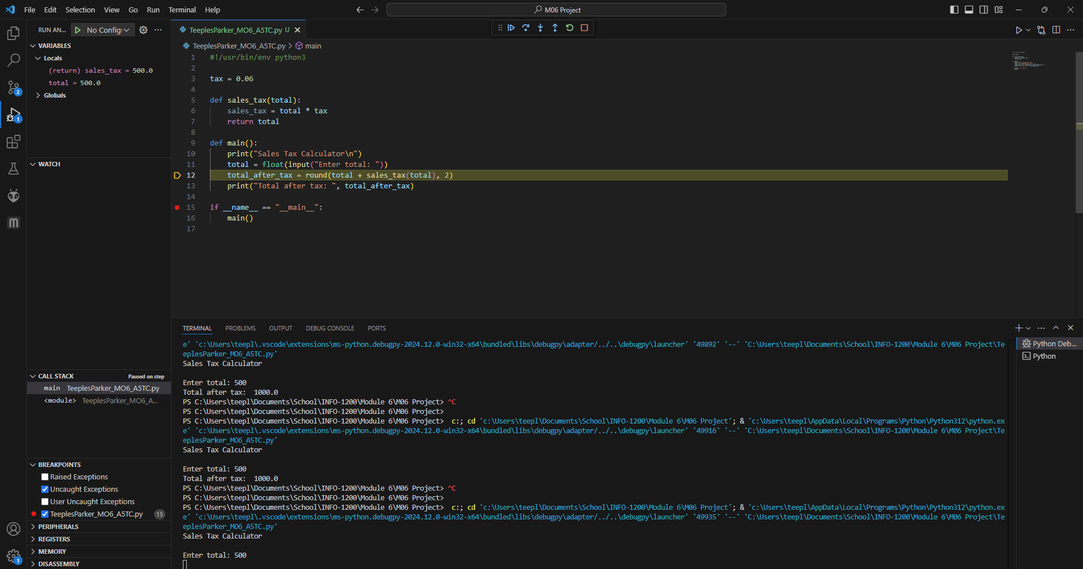

# Part 2: Debugging the Guessing Game

I started up the debugger to go through the files step by step. The first error was that the play_game function call was missing arguments, so I added the required argument. In the play_game function it tries to add one to count without count already having been created. So, I added it into the function and set it to 1 for it to work. Also, in the play_game function, the line for if the number is bigger also includes an equal sign making it, so the correct guess was never the right answer. So, I removed it. After that it seemed to work correctly.

